Ideation Phase
Empathize & Discover

Date | 03 August 2026
Team ID | N/A
Project Name | SHOPEZ E-Commerce Application
Maximum Marks | 4 Marks

Empathy Map Canvas:
An empathy map is a simple, easy-to-digest visual that captures knowledge about a user’s behaviours and attitudes.

To build an effective map for your project, gather your team and map out these core perspectives:
Think & Feel: What occupies the user's mind? What are their hidden worries, hopes, and emotional reactions?
Hear: What do friends, family, influencers, and colleagues say that influences the user's choices?
See: What does the user encounter in their environment, on competitors' sites, or in daily life?
Say & Do: What does the user outwardly state, and how do they actually act when interacting with the problem?
Pains: What are the user's biggest frustrations, obstacles, and anxieties holding them back?
Gains: What are the user's ultimate goals, desired outcomes, and measures of success?
Example: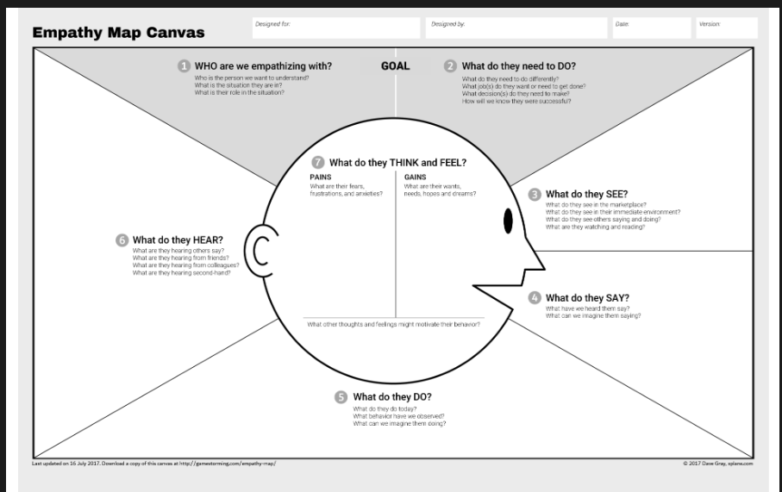
Example: Food Ordering & Delivery Application
